KallangFlow Application User Interface
Start Page, enter home location and preferred transport \

Enter accessibility needs and Click Save
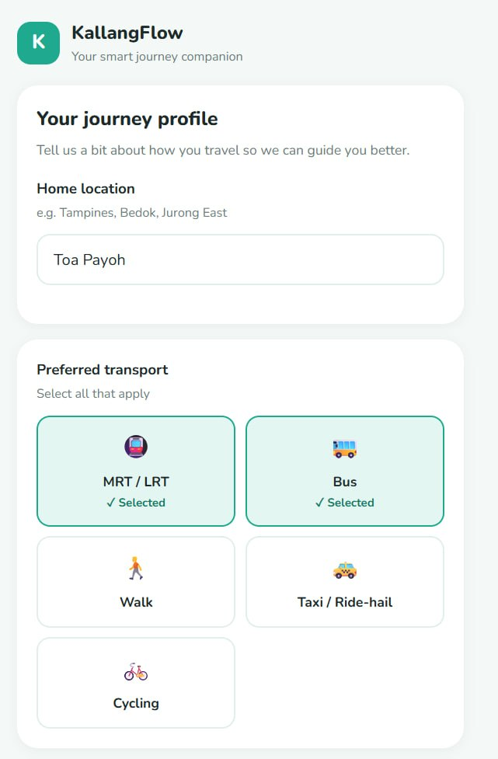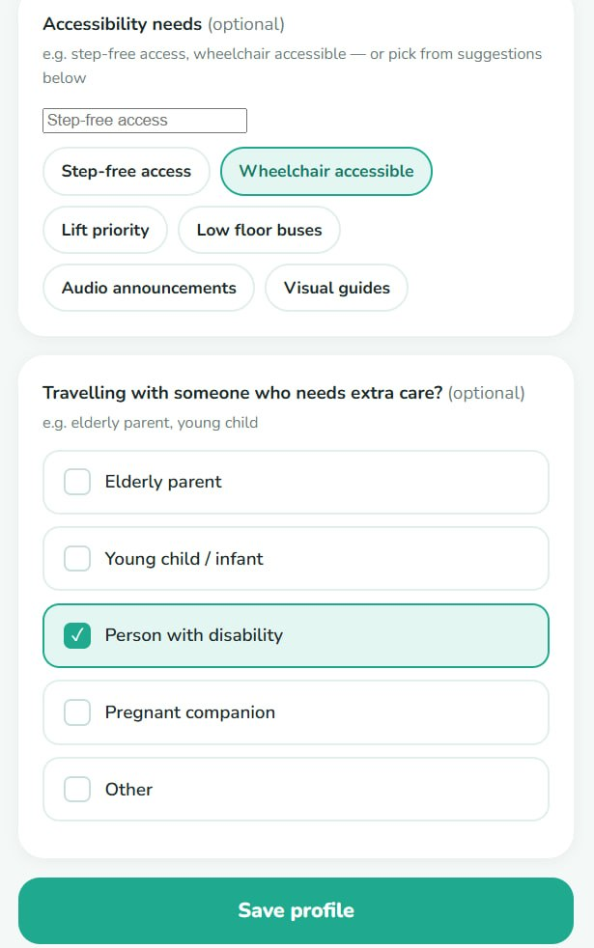

Congestion level of nearby transport options shown, scroll down to see map view
After Profile saved screen, press “Plan my Journey” to start analysis process

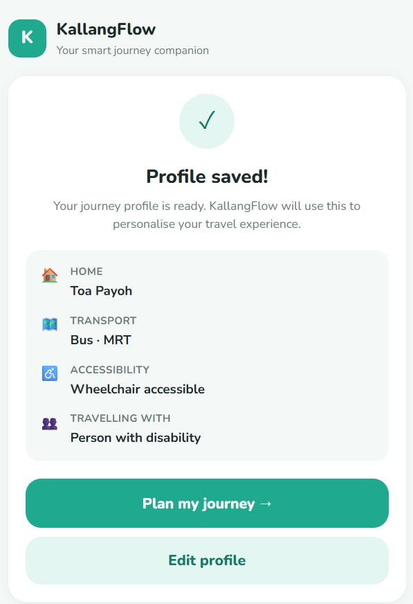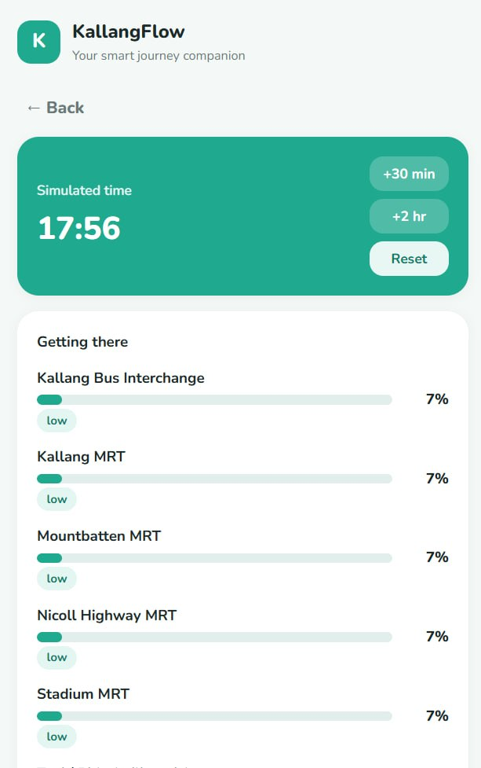

After pressing “Get my Recommendation”, the agent generates a transportation recommendation
Map View with nearby transport option locations shown
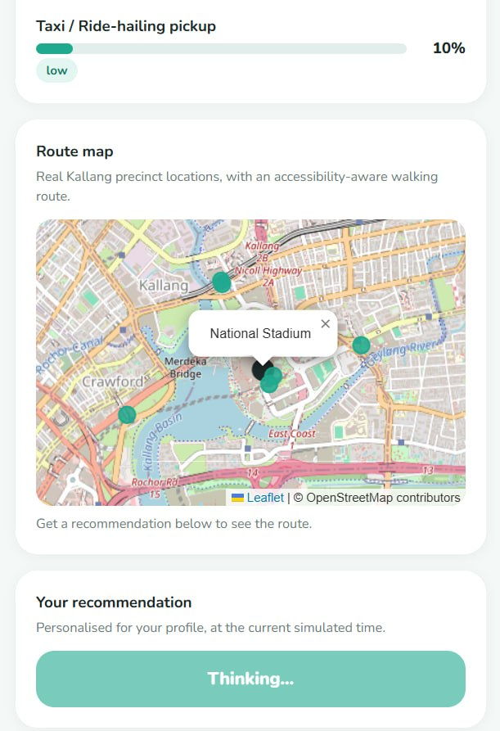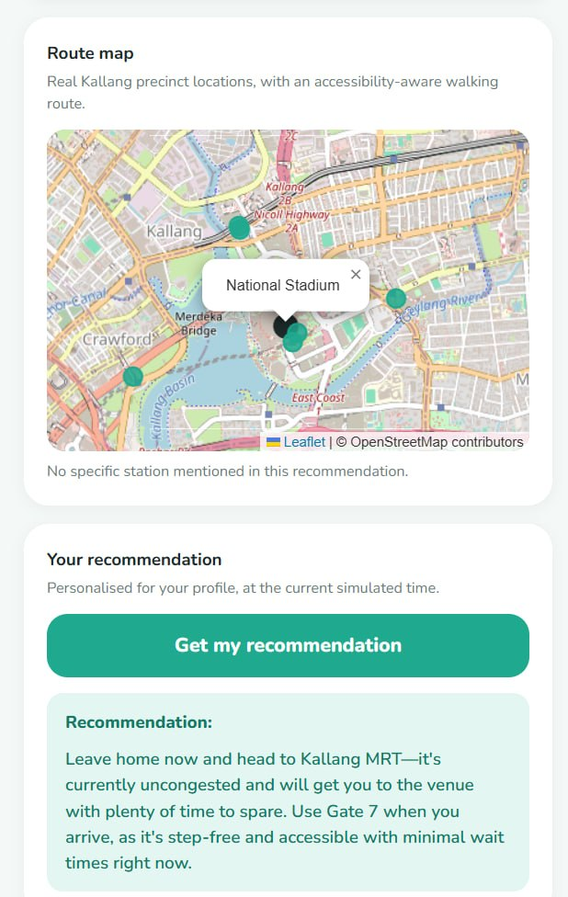
A new verdict is generated after the progression of the timer, to give recommendation for new crowd conditions
For demonstration, a simulated timer is given, to fast forward the event progression

